SUREKHA D/O RAMACHANDRAN
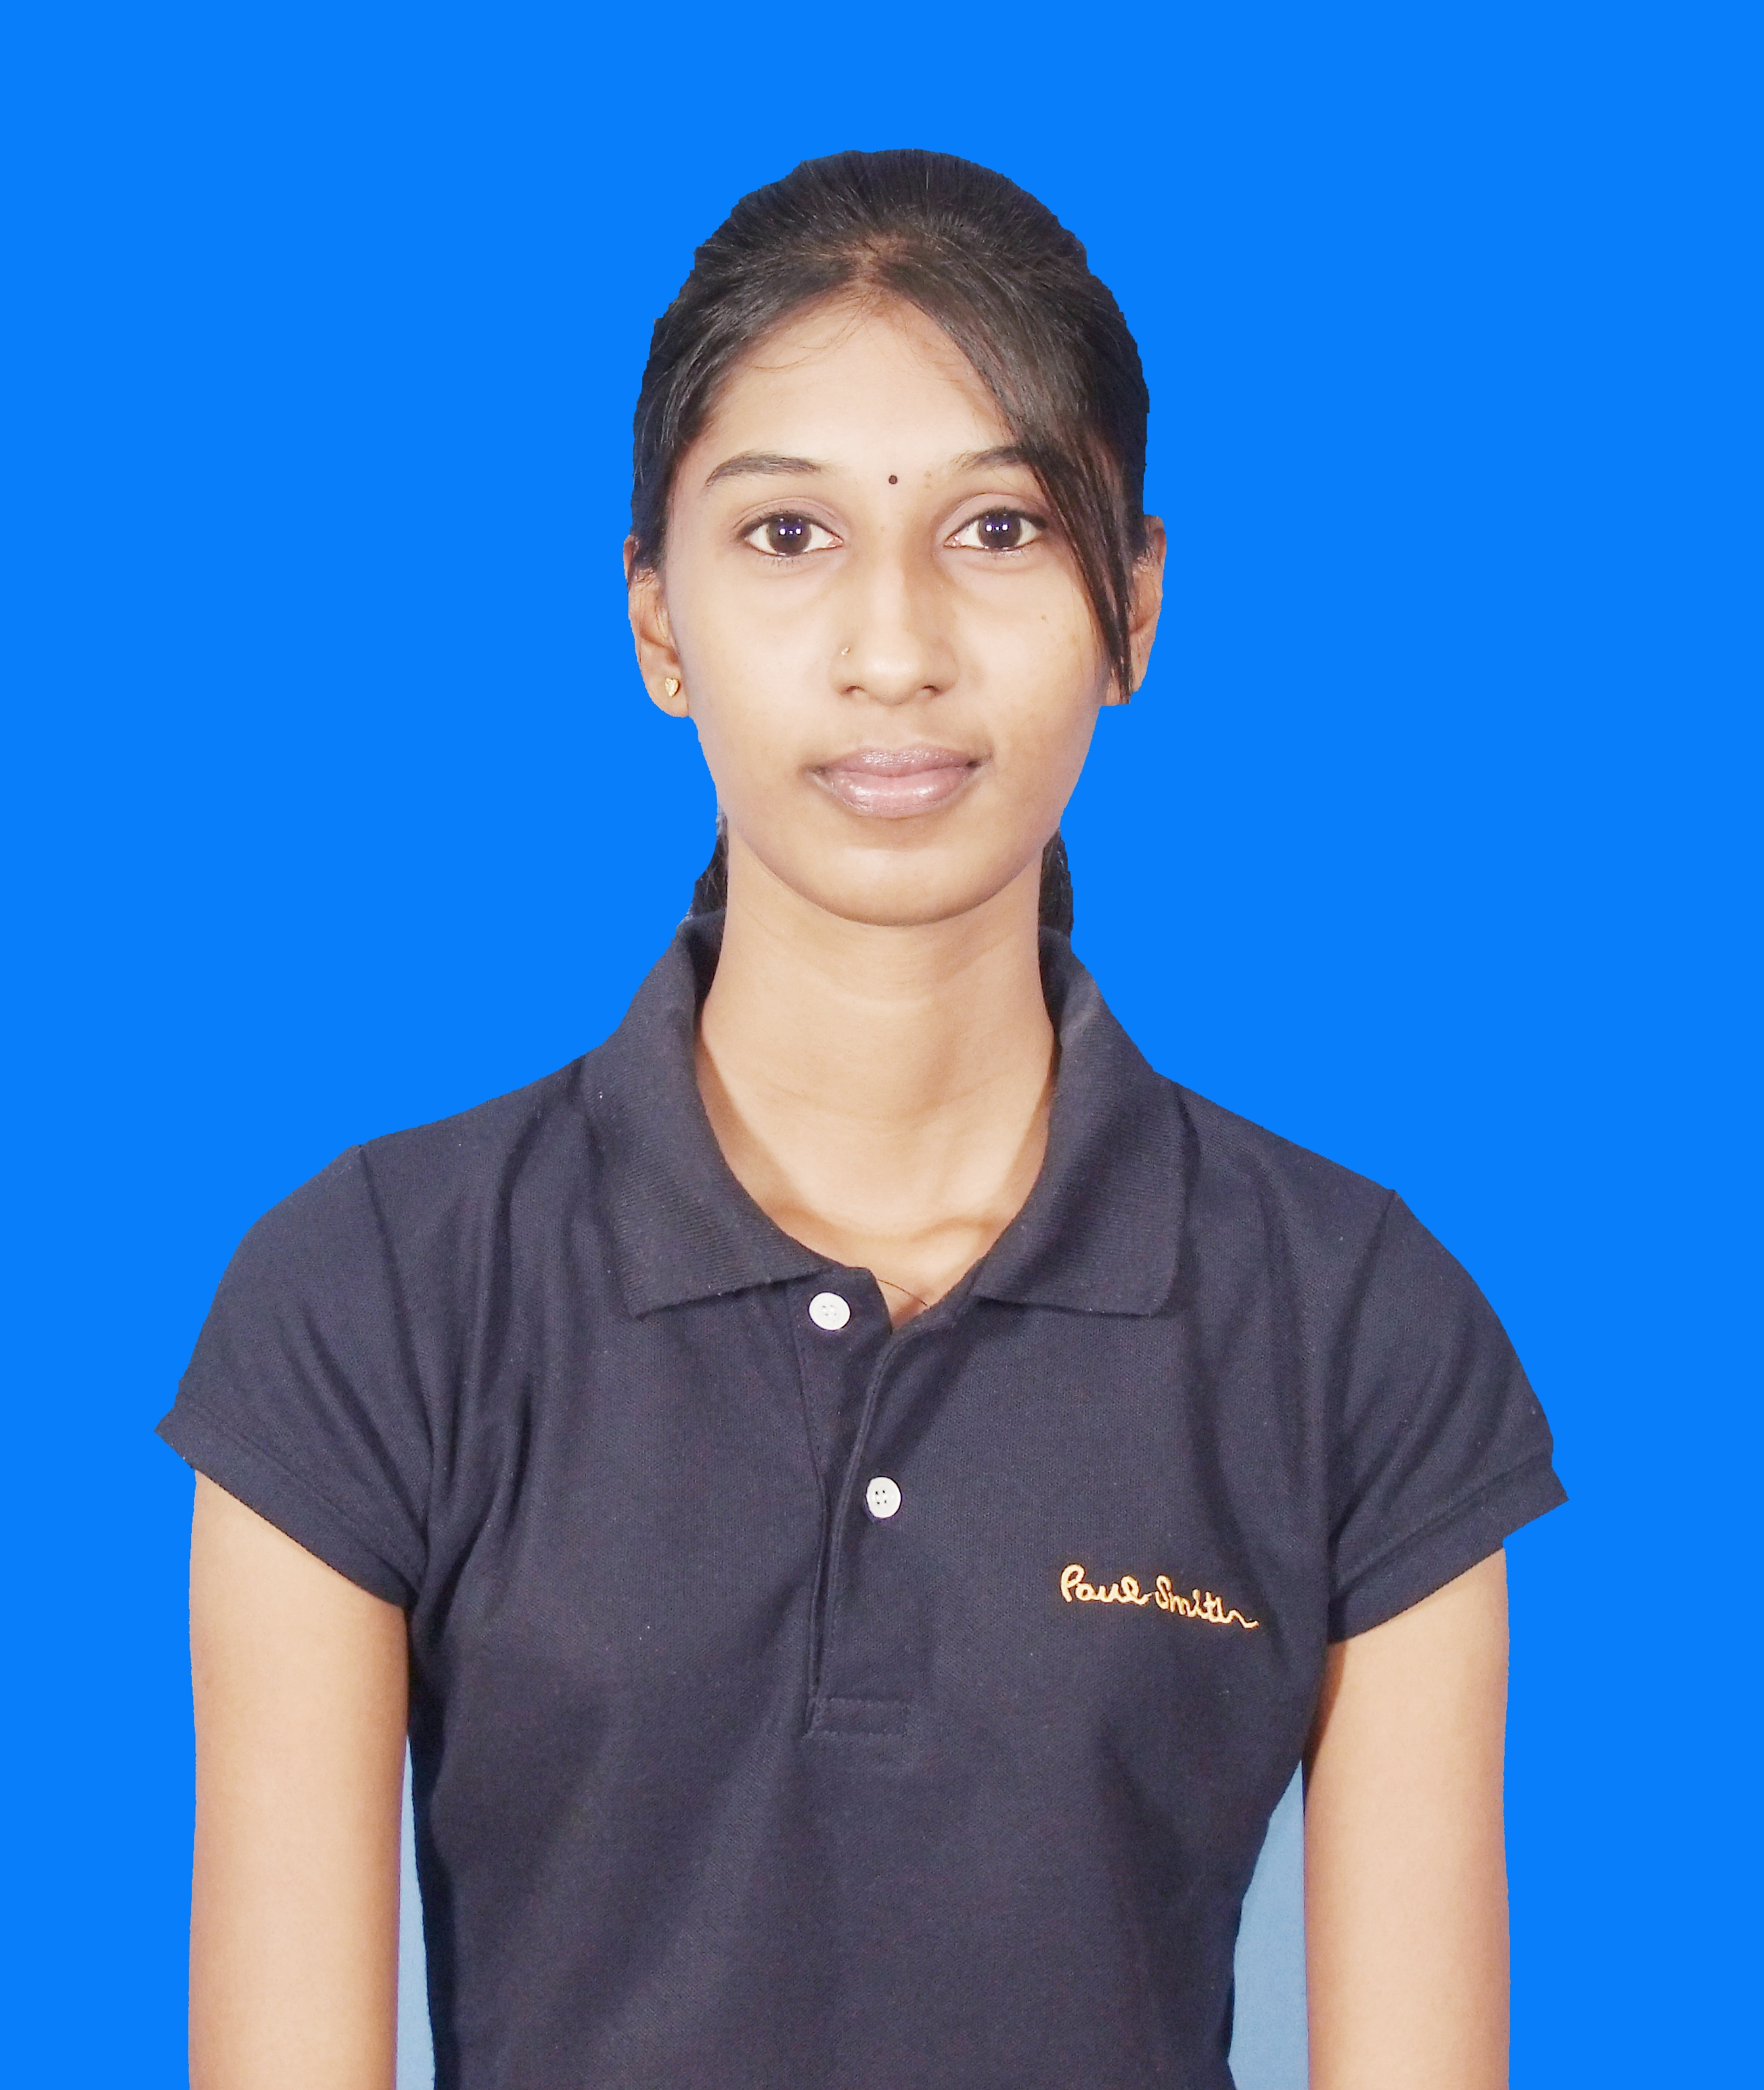
NO 44T, JALAN RAJA PERMAISURI BAINUN
OFF JALAN GOPENG,30450 IPOH,
PERAK DARUL RIDZUAN.

Hand Phone No: +601116428390
E-mail Address: surekha_8390@yahoo.com

PERSONAL PARTICULARS
Date Of Birth: | 08 March 1990 | Place Of Birth: | Hospital Besar Ipoh
Marital Status: | Single | Nationality: | Malaysian
Gender: Female

OBJECTIVE

I am seeking for a suitable position in your organization commensurate with my qualifications and experience that will enable me to build upon the skills I have.
I would like to start my career in your company as I am confident that I would be pleased to bring my leadership, versatility, and dedication to your organization. I will be a diligent and loyal employee. I am confident that I have the skills and the drive to succeed if I would be given an opportunity to join and serve your organization.

ACADEMIC QUALIFICATION
2013-2016 – QUEST International University Perak
Currently Pursuing Degree in Bachelor of Business Administration (BBA) Final Year.

2008 – 2011 Masterskill University College Of Nursing And Allied Health
Diploma in Healthcare Management (CGPA 3.15)

2003 – 2007 SMK Main Convent Ipoh, Perak SIJIL PELAJARAN MALAYSIA - Overall grading PASS

WORK EXPERIENCE
May 2012 – Aug 2013 - Experience in Admin and accounts (payroll) at Alternative Engineering Technology S/B

Oct 2011- Apr 2012 - Experience as a Team leader in the Customer service Department at Simana Network Marketing and Management Consulting Firm.

Overall Exposure Gained - Managing all administrative and accounts of the organization, able to lead a group, recruiting and train new staff on Customer Service.

EXRTA-CURRICULAR ACTIVITIES

2016 - Organized and participated in Business Symposium 3rd year.
2015 - Organized and participated in Business Symposium 2nd year.
2014 - Organized and participated in Business Symposium 1st year.
2012 - Won award as Best in Sales in Simana Network.
2010 - Participated in Futsal Competition and won 3rd placing (organized by the college).
- Participated in volunteer services for the Special Olympics Athletics at
Perak Stadium.
- Promoter at Healthcare Marketing Event.
2009 - Organize Free Medical Checkup Campaign’s for the public.
2006 - Attended 6 days school camping in Pulau Kecil Langkawi.
(Self-Independent Camping)

LANGUAGE PROFICIENCY

- Able to speak in Bahasa Malaysia, English, Tamil and learned basic Mandarin.
- Able to write in Bahasa Malaysia, and English

SKILLS / STRENGTHS

- Proficient in Microsoft Word, Excel, Power Point and AutoCAD software.
- Organizational and leadership skills and management ability.
- Experience in Admin and accounts (payroll).
- Able to maintain medical equipment records.
- Able to communicate fluently with a good public relationship.
- Skills in writing reports and capable to present well.

OTHER INFORMATION

- Can work under pressure and able to encounter any difficulty.
- Full driving license (B2 & D).
- Able to work on shift.

Salary : RM1500 (Negotiable)

REFERENCES

Name : Mrs. Anna Arokia Nathan
Programme Coordinator of Business Faculty
Quest International University
Phone No : 016-7254722

Name : Mr. Syarin
Project Supervisor
Quest International University
Phone No : 012-5893146

